iNeuron Assignment 1

Power BI desktop

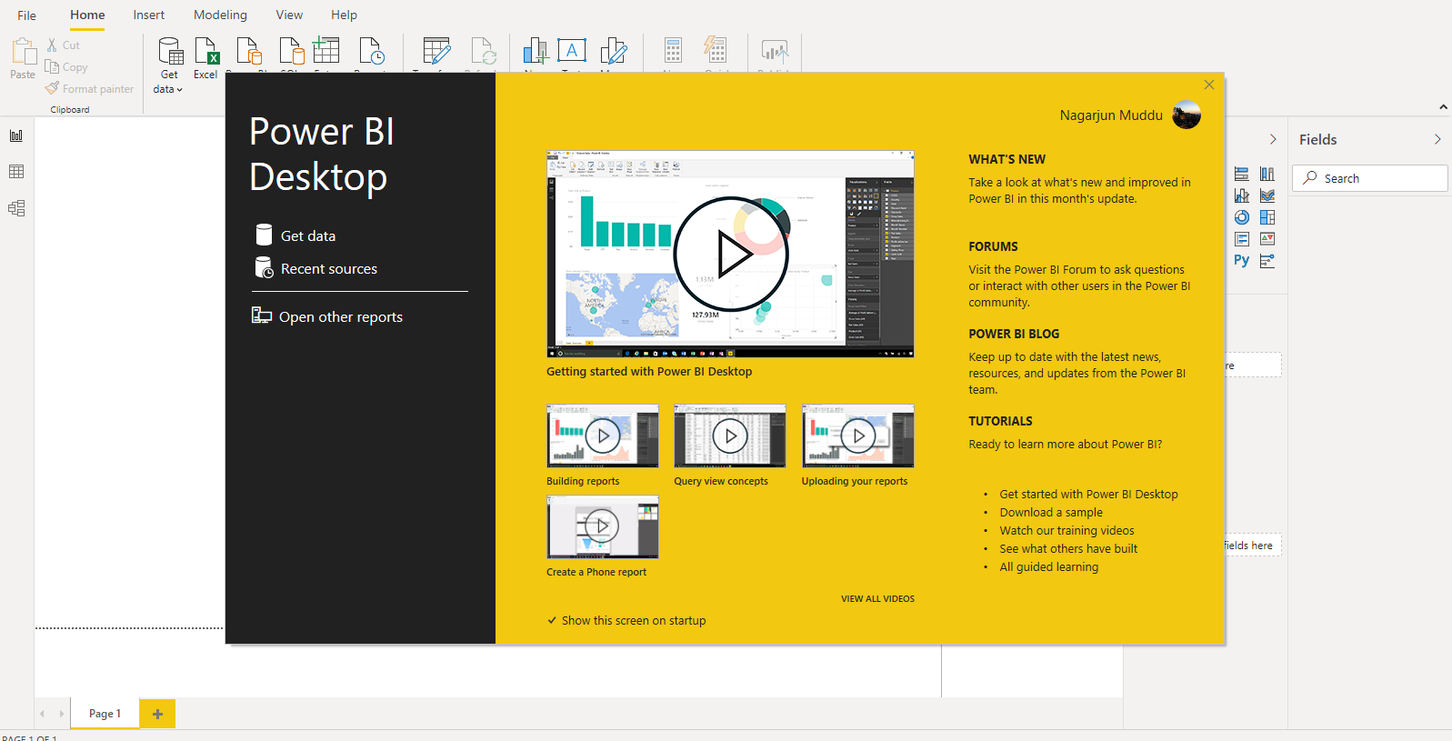

Report view

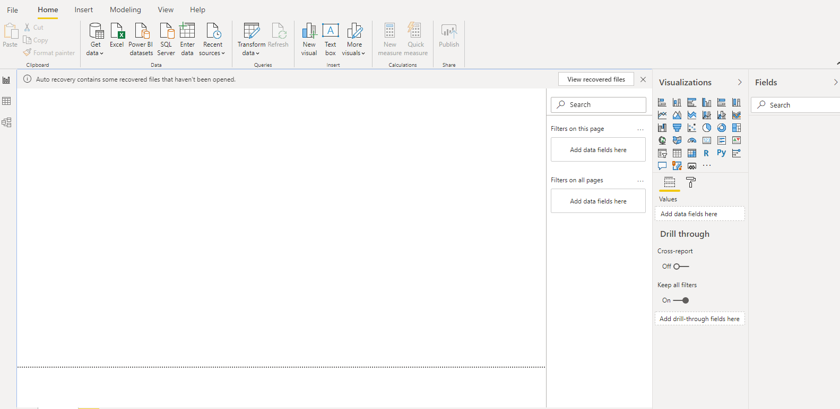

Data view:

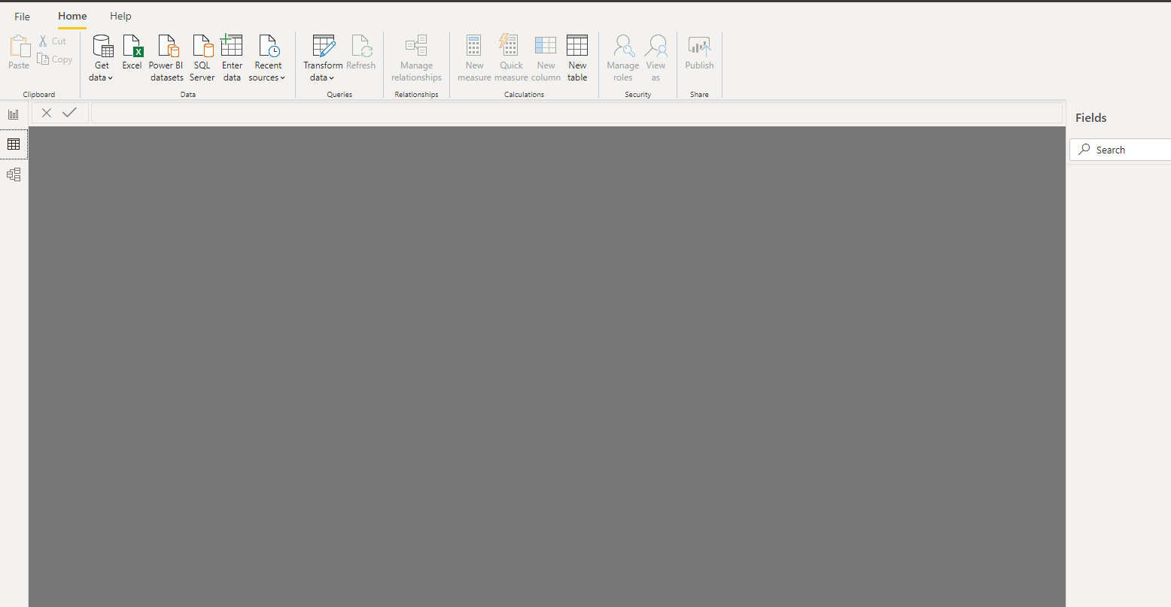

Model view:

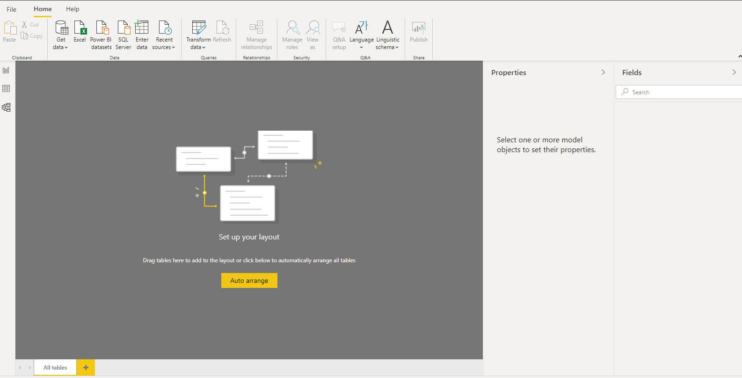

Power query editor:

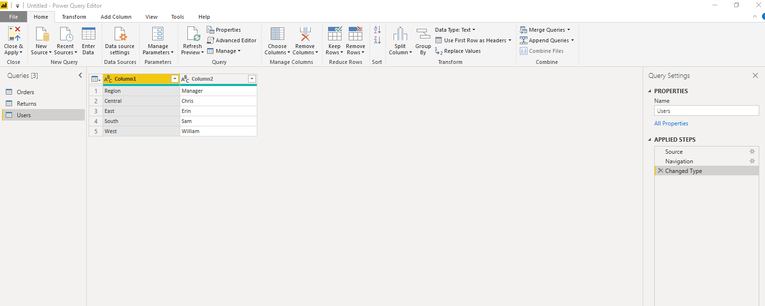

Advanced editor

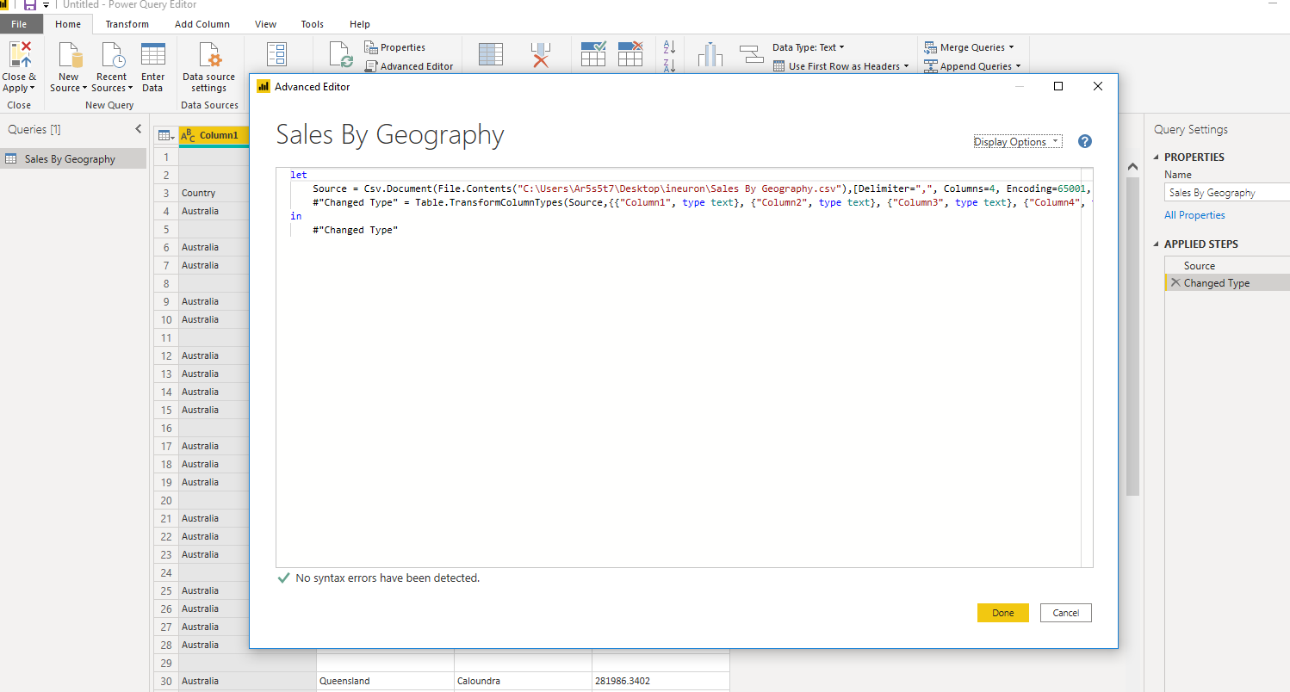

What is Power BI Desktop?

Power BI Desktop is the free version of Power BI that anyone can install on their local computer as a program, and acts as a companion desktop application to the full version of Power BI. If anyone need to consolidate their data sources, create their own reports and conduct their own analysis or test its capabilities, it’s the perfect version to start with for all skill levels - whether they are non-IT and want to make their reports more interactive, or analysts seeking richer detail, it's one of the best business analytics tools to use.

Despite its free nature, anyone may be surprised at what Microsoft has included with Power BI Desktop:

* Anyone can connect and import data from over 70 cloud-based and on-premises sources
* The same rich visualizations and filters from Power BI Pro
* Auto-detect that finds and creates data relationships between tables and formats
* Export their reports to CSV, Microsoft Excel, Microsoft PowerPoint and PDF
* Python support
* Save, upload and publish their reports to the Web and the full Power BI service
* Storage limit of 10 GB per user

Naturally, there are some feature limitations with the free Power BI Desktop that give further incentive to upgrade.

* Can’t share created reports with non-Power BI Pro users
* No App Workspaces
* No API embedding
* No email subscriptions
* No peer-to-peer-sharing
* No support to analyze in Excel within Power BI Desktop

To be very clear: All of Power BI’s basic features - cleaning and preparing data, connectors to data sources, custom reports, visualizations and exports to Microsoft apps are included in Power BI Desktop. Thus, whatever core functionality or features are available in Power BI Desktop are also standard in the higher-tier, paid versions.

How do I get Power BI Desktop?

It doesn’t need a Microsoft Office 365 subscription of any sort to use Power BI Desktop.

Power BI Desktop is a free download available directly from Microsoft as MSI package, with Windows 10, Windows 7, Windows 8, Windows Server 2008 R2, Windows Server 2012 and Windows Server 2012 R2 operating systems currently supported.

Anyone can download and install the Power BI Desktop app from the Microsoft Store, which offers additional benefits such as automatic updates whenever feature upgrades or patches are released by the development team. Anyone can’t, however, have both versions installed at this time.

What is Power BI Pro?

Power BI Pro is the full version of Power BI, complete with the ability to use Power BI for both building dashboards and reports and unlimited viewing, sharing and consumption of their created reports (and reports shared by others) - the latter not possible with Power BI Desktop.

A breakdown of Power BI Pro’s differences against Power BI Desktop:

* Ability to embed Power BI visuals into apps (PowerApps, SharePoint, Teams, etc)
* Native integration with other Microsoft solutions (Azure Data Services)
* Share datasets, dashboards and reports with other Power BI Pro users
* Can create App Workspaces and peer-to-peer sharing

Power BI Pro is licensed by individual user. For example, if the organization has 20 people that need to full capabilities of self-service BI to create dashboards and reports, anyone need 20 licenses of Power BI Pro, which gives these users full access to creation of reports and unlimited consumption (viewing) of any created content.

In case of lot of users, Power BI Pro can obviously become quite expensive - but there’s a better option if anyone have more users that need to consume reports than use Power BI for creating reports, which we detail below.

What is Power BI Premium?

Power BI Premium is the most expensive tier of Power BI currently available and very distinct from the other two versions available on the market.

On top of the features and functionality standard to all versions of the service, users of Power BI Premium get:

* Increased data capacity limits and maximum performance
* Access to one API surface
* Ability to embed Power BI visuals into apps (PowerApps, SharePoint, Teams, etc)
* Larger storage sizes for extended deployments
* Geo distribution, higher refresh rates, isolation, pin to memory, read-only replicas
* Power BI Report Server

Power BI Premium differs from the free version and Power BI pro in its licensing model, which only suits a specific size and type of organization and business scenario. Anyone can purchase Premium in a range of capacity sizes that offer different numbers of memory and virtual cores that can scale as their data analysis requirements change.

With Power BI Premium, licensing capacity for datasets, dashboards and reports, not just licensing all users of that content. In other words, It buying licenses in bulk to allow a large number of users to use Power BI to view reports. All the content is stored in Premium and can then be viewed by as many users in the organization.